NAME: BANDLAPALLI BHANUTEJA REDDY

REG-NO: 192325016

1.Linear regression

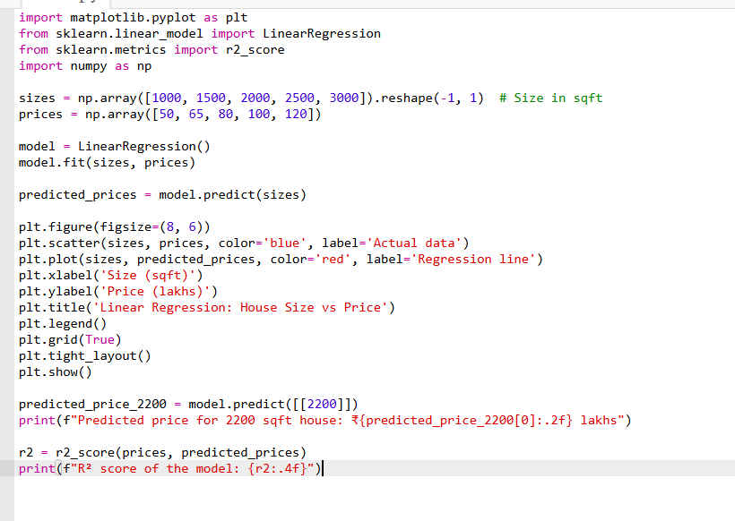

Output:

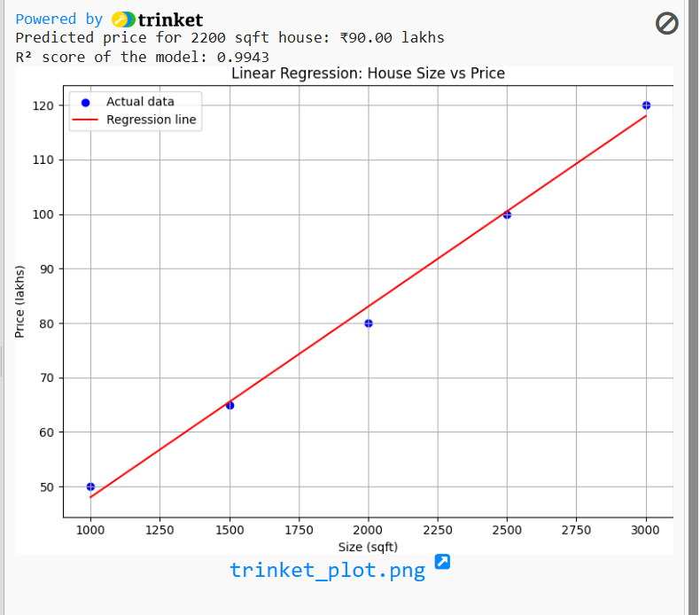

2.Logistic regression

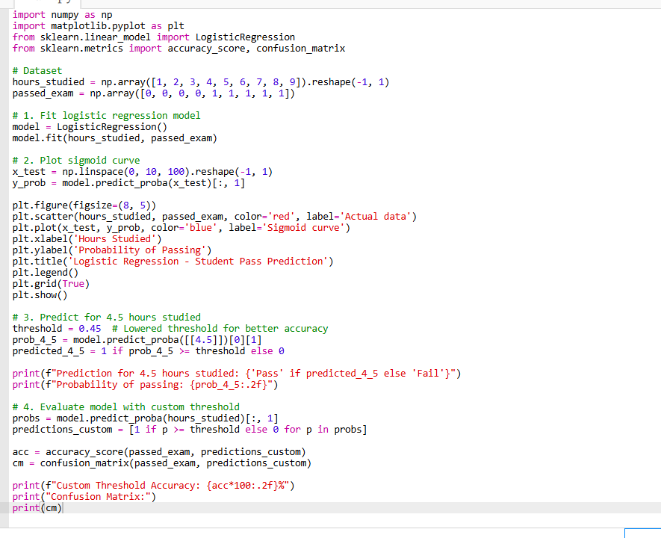

Output:

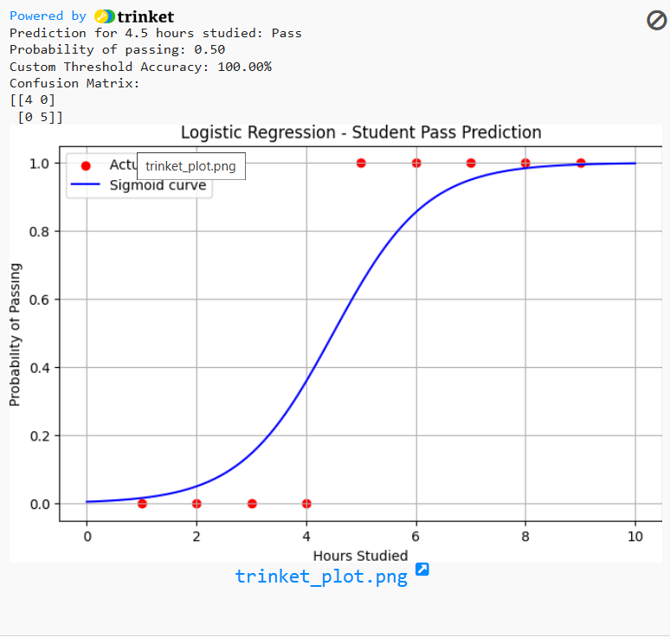

3.Find-S-algorithm

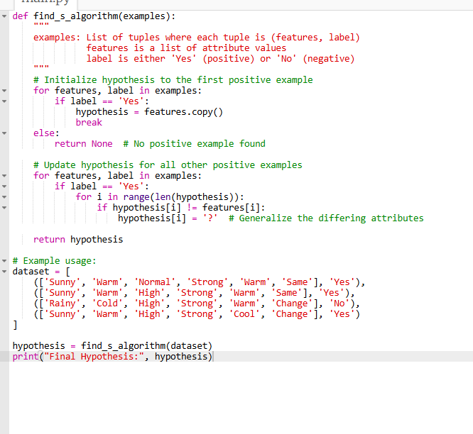

Output:

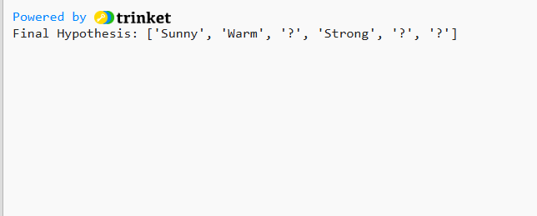

4.Candidate elimination algorithm

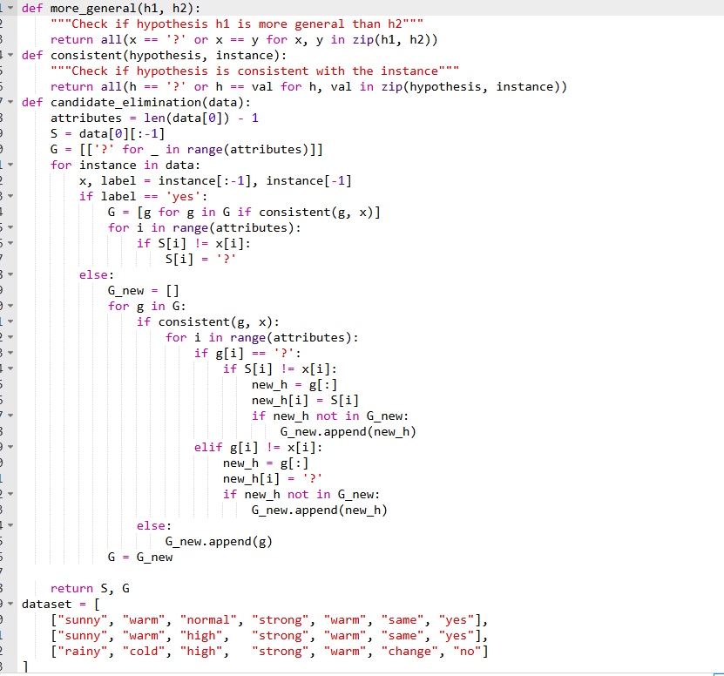

Output:

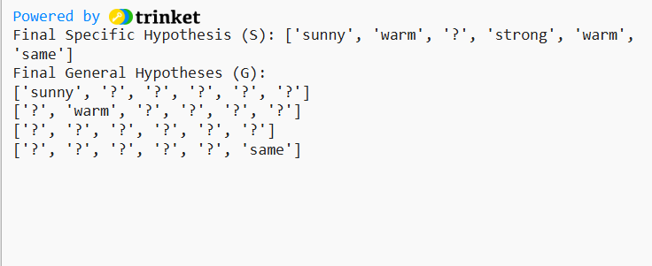

5. Write a program for Implementation of K-Nearest Neighbours (K-NN) in Python

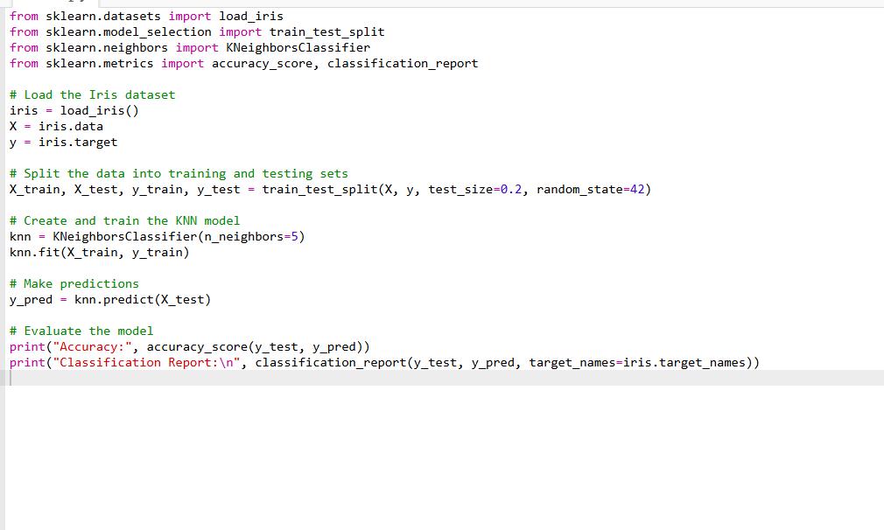

Output

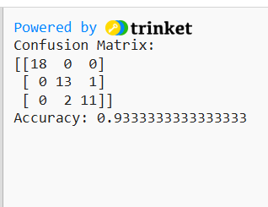

6. Write a program to implement Naïve Bayes algorithm in python and to display the results using

confusion matrix and accuracy.

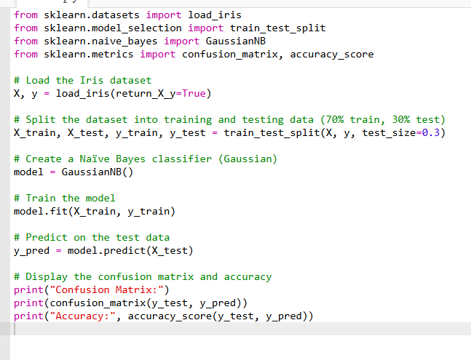

Output:

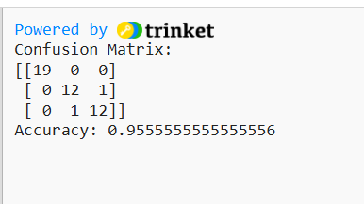

7. Write a program to implement Logistic Regression (LR) algorithm in python

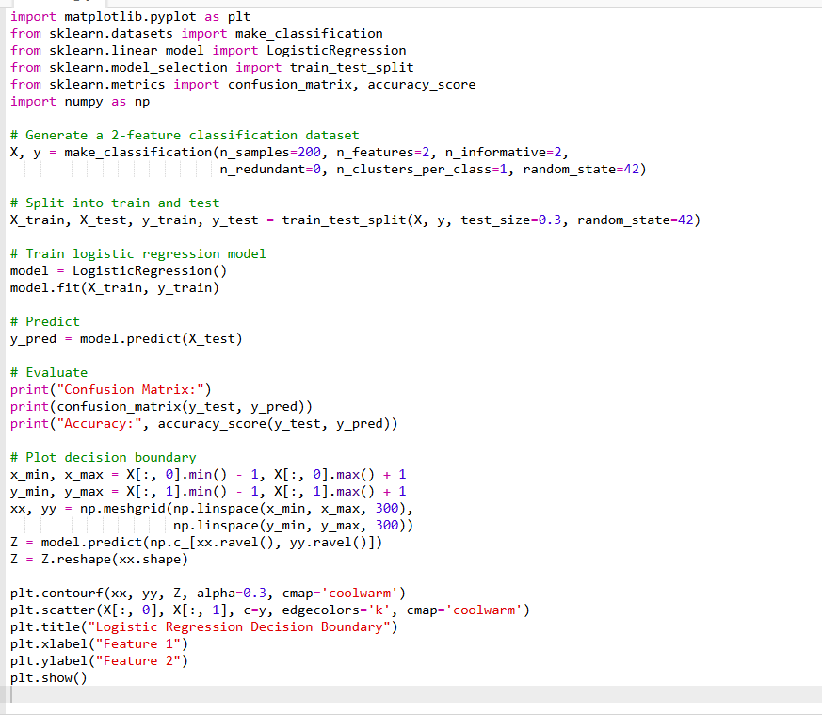

Output:

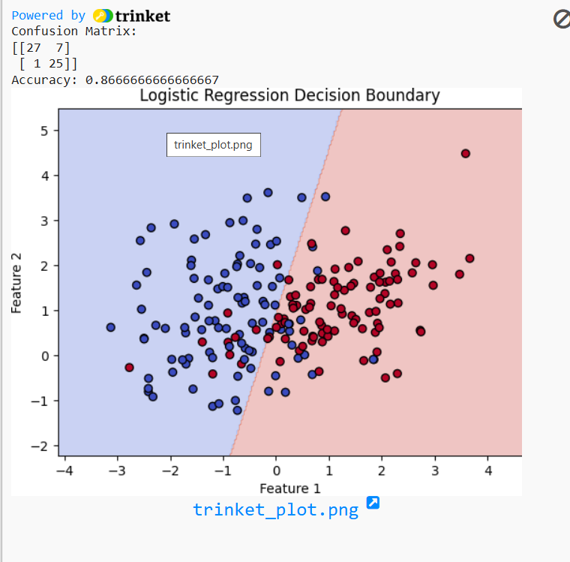

8. Write a program to implement Linear Regression (LR) algorithm in python

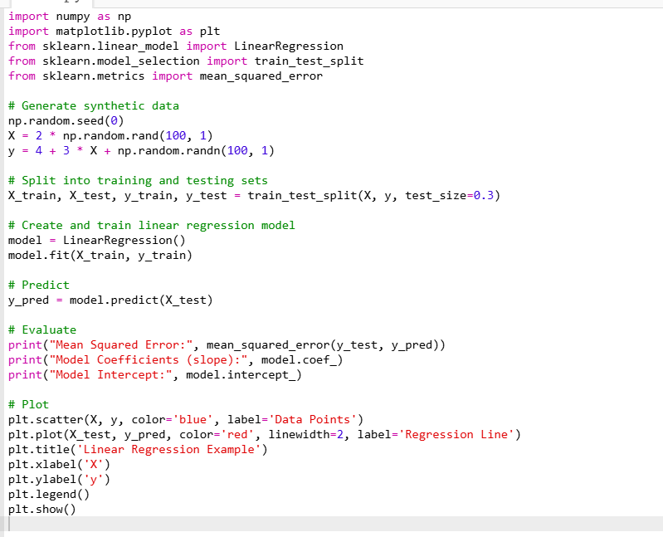

OUTPUT:

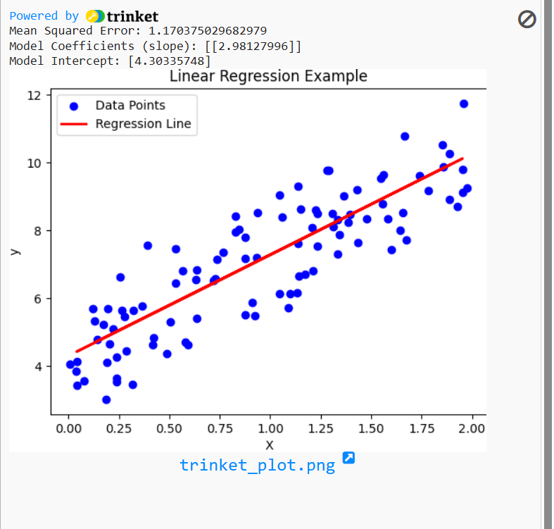

9. Compare Linear and Polynomial Regression using Python

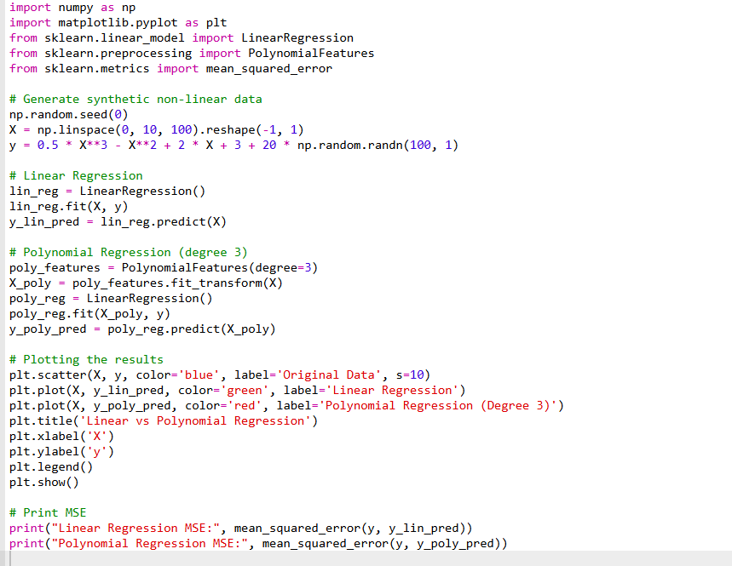

OUTPUT:

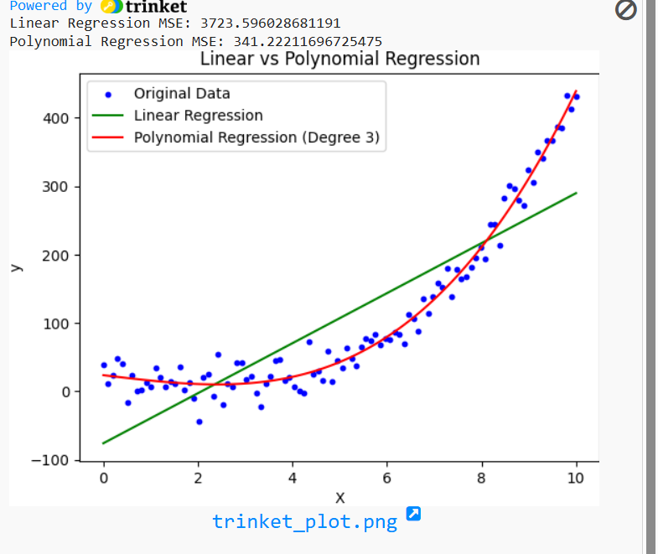

10. Write a Python Program to Implement Expectation &amp; Maximization Algorithm

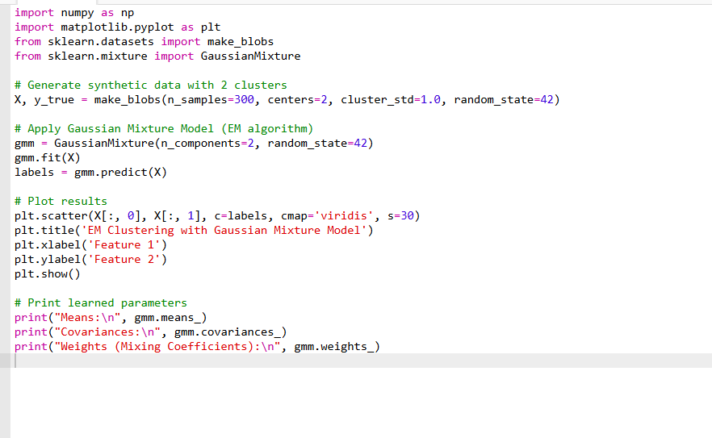

OUTPUT:

